Foundations of Data Science (CS F320)

Assignment 2

**Part A: Circle Approximation**

**Sample Size: 10**

**Pi Value: 3.6**

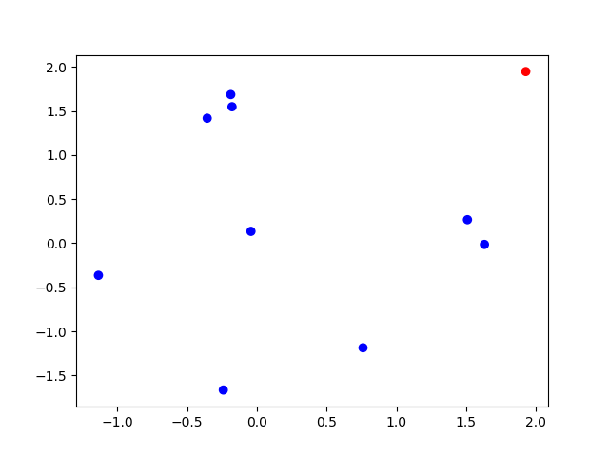

**Sample Size:100**

**Pi Value: 3.24**

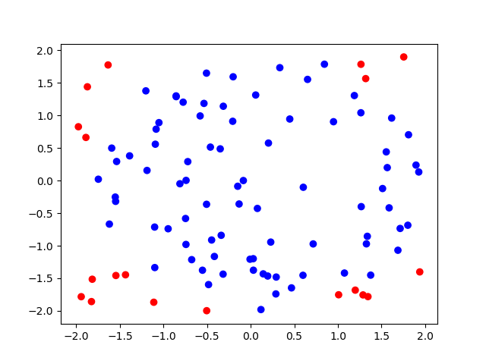

**Sample Size:1000**

**Pi Value: 3.1052**

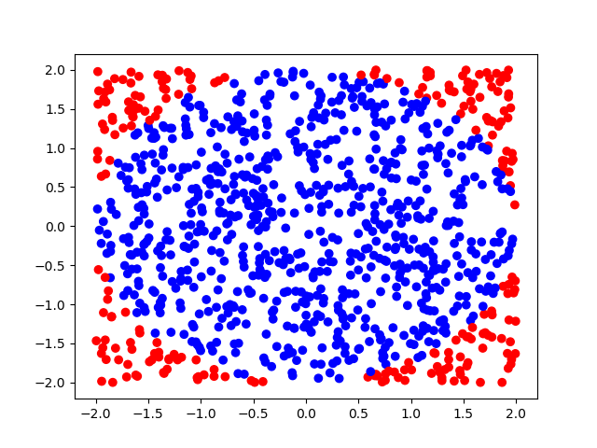

**Sample Size: 10000**

**Pi Value: 3.1496**

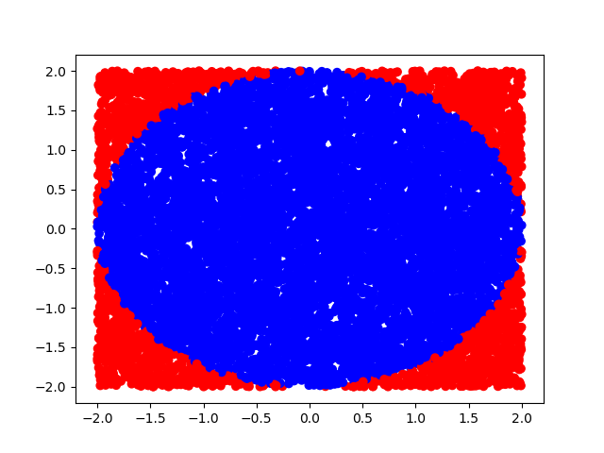

**Sample Size:100000**

**Pi Value: 3.14262**

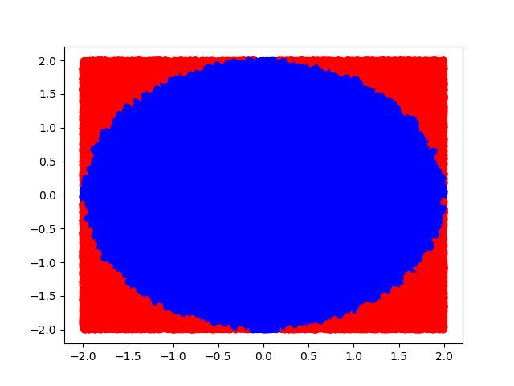

**Sample Size: 1000000**

**Pi Value: 3.140448**

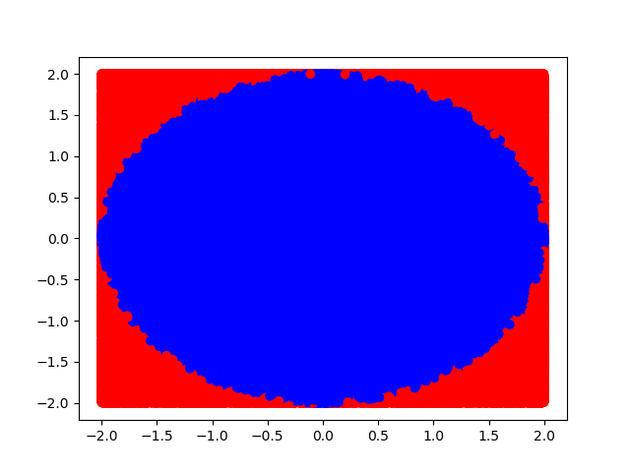

**Sample Size: 10000000**

**Pi Value: 3.141652**

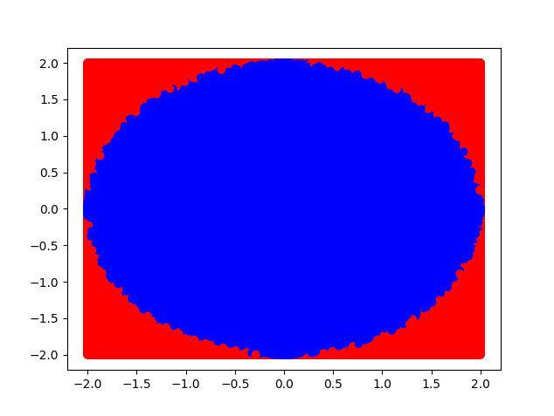

**Part B: Sphere Approximation**

**Sample Size: 10**

**Pi Value: 3.6**

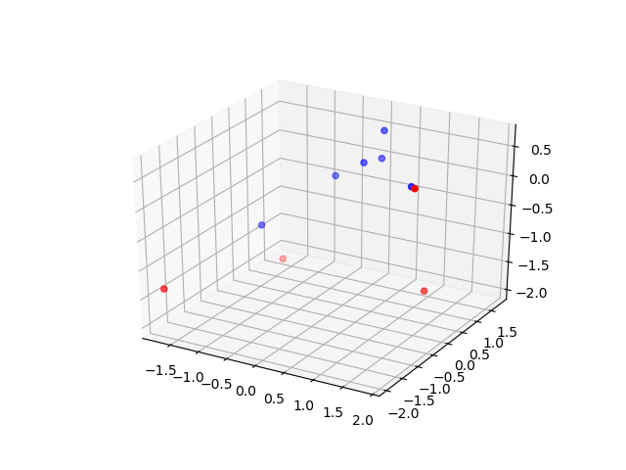

**Sample Size: 100**

**Pi Value: 3.48**

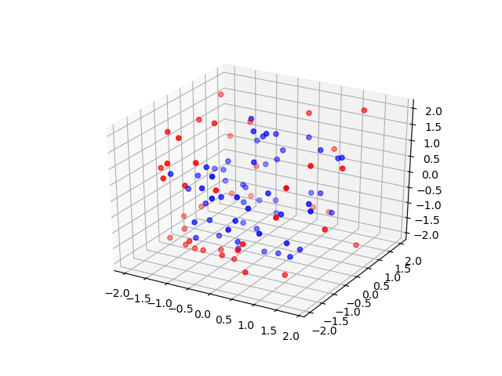

**Sample Size: 1000**

**Pi Value: 3.138**

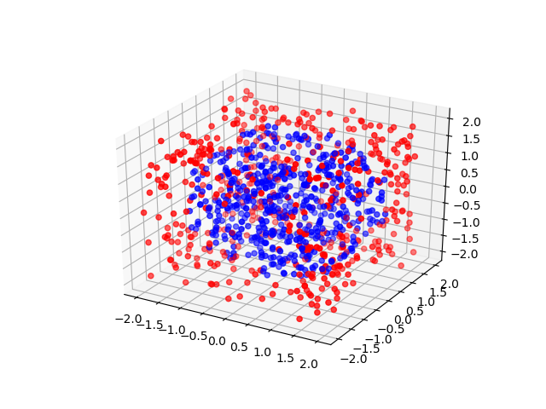

**Sample Size:10000**

**Pi Value: 3.1338**

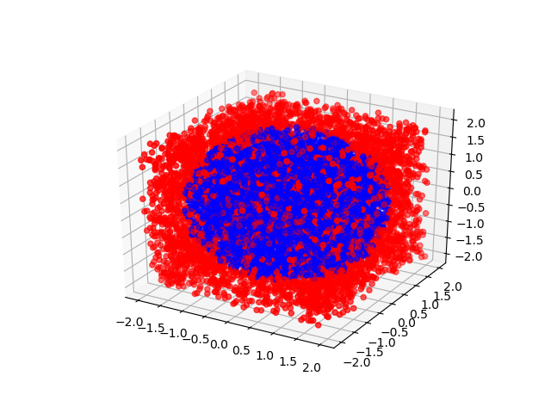

**Sample Size:100000**

**Pi Value: 3.14334**

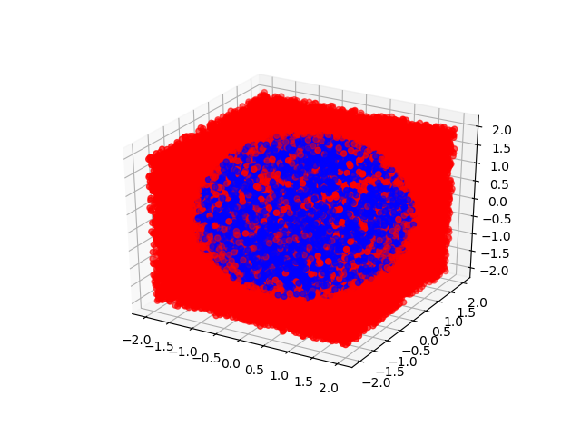

**Sample Size:1000000**

**Pi Value: 3.146386**

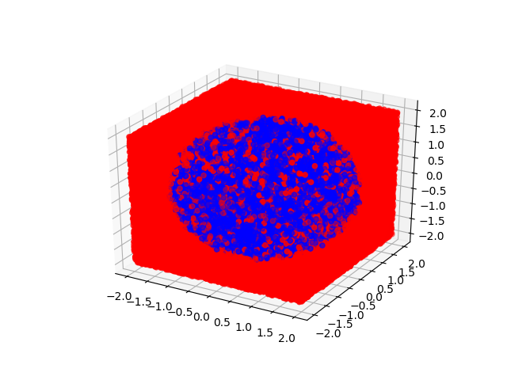

**Sample Size: 10000000**

**Pi Value: 3.142158**

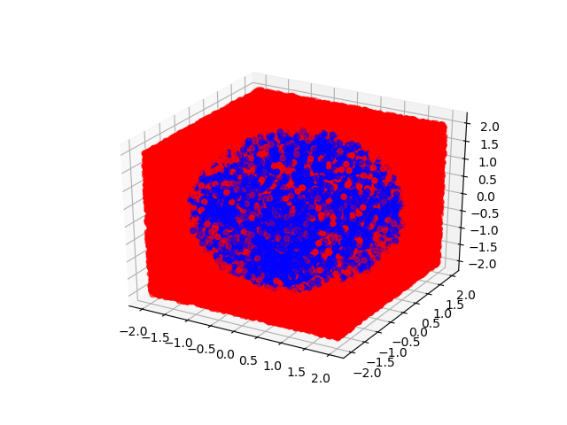

**Part C: Analysis**

The estimates of Pi have been very similar for various sample sizes using both the methods. Also since the points in a sphere tend to be more spread out across 3 dimensions compared to a circle, the points that are randomly sampled each time are less likely to satisfy the condition to be included in the sphere. Hence the estimate of Pi converges at a faster rate to its true value as the sample size increase in the case of the circle.